How to Modify the Display Direction

1、GPIO port type LCD Rotation Methods：

Apply to GPIO port LCD(2.4 inch,2.8 inch,3.2 inch,3.5 inch).

Execute command at terminal：

sudo nano /boot/config.txt

If using 2.4 inch/2.8 inch/3.2 inch LCD, please find”dtoverlay=tft9341”,then add rotate parameter, and do as follows：

dtoverlay=tft9341:rotate=value

If using 3.5 inch LCD, please find”dtoverlay=tft35a”then add rotate parameter, and do as follows：

dtoverlay=tft35a:rotate=value

We take 3.5inch LCD for example:

For rotation of 0 degree(vertical screen), the corresponding value is:

dtoverlay=tft35a:rotate=0

For rotation of 90 degree(horizontal screen), the corresponding value is:

dtoverlay=tft35a:rotate=90

For rotation of 180 degree(vertical screen), the corresponding value is:

dtoverlay=tft35a:rotate=180

For rotation of 270 degree(horizontal screen), the corresponding value is:

dtoverlay=tft35a:rotate=270

Press Ctrl + X, select Y, save and exit.

2、HDMI port type LCD Rotation Methods：

This method just applies to the HDMI interface type LCD( such as 3.97inch, 4.3inch,5 inch,7 inch model B,7 inch model C,10.1 inch)
Execute command at terminal:

sudo nano /boot/config.txt

Find “display_rotate”, if there is not, please add it in

There are the meaning of parameter “display_rotate”

display_rotate | result
0 | no rotation
1 | rotate 90 degrees clockwise
2 | rotate 180 degrees clockwise
3 | rotate 270 degrees clockwise
0x10000 | horizontal flip
0x20000 | vertical flip

For rotation of 0 degree, the corresponding value is:

display_rotate=0

For rotation of 90degrees, the corresponding value is:

display_rotate=1

For rotation of 180 degrees, the corresponding value is:

display_rotate=2

For rotation of 270 degrees, the corresponding value is:

display_rotate=3

For horizontal flip display, the corresponding value is:

display_rotate=0x10000

For vertical flip display,the corresponding value is:

display_rotate=0x20000

Press Ctrl + X, select Y, save and exit.

As picture:
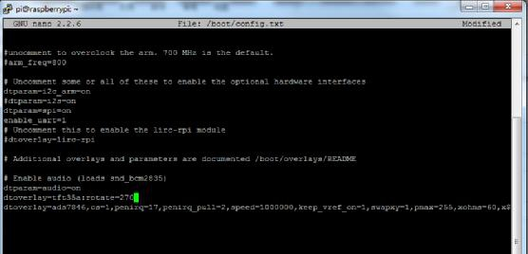

3、Modify touch parameters

When the display direction changes, we also need to modify “99-calibration.conf”file to set the touch.And then execute command

sudo nano /etc/X11/xorg.conf.d/99-calibration.conf

Take 5 inch HDMI LCD for example:

The default parameter is 0 degree, that is, display_rotate=0, the corresponding touch calibration parameters are:
Section "InputClass"
Identifier |  | "calibration"
MatchProduct |  | "ADS7846 Touchscreen"
Option | "Calibration" |  | "140 3951 261 3998 "
Option | "SwapAxes" |  | "0"
EndSection

For rotating 90 degrees to display, that is, display_rotate=1, the corresponding touch parameters are modified as:

Section "InputClass"
Identifier |  | "calibration"
MatchProduct |  | "ADS7846 Touchscreen"
Option | "Calibration" |  | "261 3998 3951 140"
Option | "SwapAxes" |  | "1"
EndSection

For rotating 180 degrees to display, that is, display_rotate=2, the corresponding touch parameters are modified as:

Section "InputClass"
Identifier |  | "calibration"
MatchProduct |  | "ADS7846 Touchscreen"
Option | "Calibration" |  | "3951 140 3998 261"
Option | "SwapAxes" |  | "0"
EndSection

For rotating 270 degrees to display, that is, display_rotate=3, the corresponding touch parameters are modified as:

Section "InputClass"
Identifier |  | "calibration"
MatchProduct |  | "ADS7846 Touchscreen"
Option | "Calibration" |  | "3998 261 140 3951"
Option | "SwapAxes" |  | "1"
EndSection/

When modified, restart to see the effect.

sudo reboot

